

Procedure
Removing Operator Cert from AMI AP and NIC
CitiPower Pty Ltd, Powercor Australia Ltd
and United Energy Services Pty Ltd
PR-XXXX

Disclaimer
The master document is controlled electronically.
Ensure latest version prior to use.

Based on CPPAL Style Guide, TP-0008 Tri-Brand Procedure Template Revision 230224
Document controlled in accordance with ST-1750 INMS Document Management Standard

Document Control
Reviewer | Signature | Date
Insert Name and Title | {{Sig_es_:signer2:signature}} | {{Dte_es_:signer2:date}}

Approver | Signature | Date
Insert Name and Title | {{Sig_es_:signer3:signature}} | {{Dte_es_:signer3:date}}

Version | Amendment Overview | Author
1 | Initial Version | Jie Zhao  Senior Engineer, AMI Metering and Communciations  {{Sig_es_:signer1:signature}}  {{Dte_es_:signer1:date}}

When adding additional versions, please type the previous author’s name and the approved date into the ‘author’ column and ensure the Adobe Sign ‘signer1 text tags’ only appear on the latest version to be signed.
If additional signatories are needed, please continue the Adobe Sign numbering sequence. E.g. signer1, signer2, signer3, signer4 etc.

Table of Contents
1. Purpose 1
2. Document Scope 1
3. Objective 1
4. Responsibilities 1
4.1 United Energy 1
4.1.1 Electricity Networks 1
4.1.2 Service Delivery 1
4.2 CitiPower/Powercor 1
4.3 Service Provider 1
5. Procedure 1
6. Implementation and Compliance 1
7. Referenced Documents 2
8. External References 2
8.1 Australian Standards 2
8.2 International Standards 2
9. Definitions 2
10. Landscape Page 3
Appendix A: Insert Heading Here 4

List of Figures
Figure 1: CPU Figure Caption Inserted Below the Image. 1

List of Tables
Table 1: Referenced Documents 2
Table 2: Australian Standards 2
Table 3: International Standards 2
Table 4: Terms and Definitions 2

- Purpose
The purpose of this document is to describe the process for removing Operator Certificate from AMI Access Points, Relays and NICs, and thus allow moving them into another UIQ environment..
This document shall be reviewed regularly and amended as required in order to reflect changes in design and construction standards, the application of new technologies, or changes to network operations and field experience.
- Document Scope
This procedure only applies to AMI AP/Relay/NICs that have already received Operator Certificate of a particular UIQ environment, e.g.: Prod UIQ, and user wishes to remove the Operator Certificate so that the device can be troubleshooted further, or moved to another environment, e.g.: to any Non Prod UIQ environment

In VPN/UE setup, Prod UIQ has their own OP Certificate. For all Non-Prod UIQ environments at VPN or UE, they share same OP Certificate.

If you are moving just a Relay or NIC from Prod to Non-Prod UIQ, this documents is sufficient enough, as they just need OP Cert to be removed, DNS setting updated and Network ID updated, all by CATT.

If you are moving AP and MicroAP from Prod to Non-Prod, or vice versa, you must follow another more complicated procedure " Repurposing AP5 Micro AP into another UIQ environment.docx".
- Objective
This procedure applies to any Itron AMI Access Point, Relay or NIC that have already been bonded with a specific UIQ environment, and end user wishes to remove their UIQ environment specific Operator certificate, in order to troubleshoot them or move then into another UIQ environment.

The document captures operational steps of generating Operation Cert Delete permit file from UIQ then using the permit file for deleting Operator Certificate from the AMI AP. Relay or NIC.
- Responsibilities
  - United Energy
    - Electricity Networks
The Electricity Networks team shall be responsible for….
    - Service Delivery
The Service Delivery team shall be responsible for…
  - CitiPower/Powercor
The Electricity Networks team shall be responsible for….
  - Service Provider
The service provider shall be responsible for…
- Procedure
Note: For any brand-new AMI AP/Relay/NICs, they do not contain operator certificate when you first power up the devices. However, they will acquire an OP cert if you

- Leave them exposed to an active AMI mesh radio network, or
- AP/MicroAp successfully called home and gets updated by Gridscape, or
- You make a Secured Connection with them with an FSU. Connecting device with Clear Text or Null mode do not push OP cert on the FSU to the AMI AP/Relay/NICs.

  - Prerequisite:
Request NOC/UIQ Support team to
- Generate operator delete certificate which is going to be used by FSU-SAM for RMA Prep.
- Configure the HSM Slot to have this newly generated cert

The cert usually only last a week. So make sure that you work with NOC/UIQ Support team to get FSU-SAM cert configured properly.
• NICs running firmware versions 3.4.1 or above.
• Communications Tester 6.4 or above when Legacy Port is off. If Legacy Port is not disabled,
you can use an older version of Communications Tester, but you must run it in Null Mode.
  - FSU-SAM Operation
Open FSU-SAM of the UIQ environment that AMI devices are currently bond to.

The example below shows steps of removing OP Cert from Prod UIQ. Hence we open FSU-SAM of the Prod UIQ:

Choose Tab “Op Cert Removal/ RMA Prep”, then choose "OP Cert Removal"
Put the MAC address of the PROD AP5 into MAC list section.
Duration: 12 Hours
Operation: Remove Operator.
Hit Submit.
FSU SAM will generate a file permit.zip, download the .zip file. DO NOT unzip it.
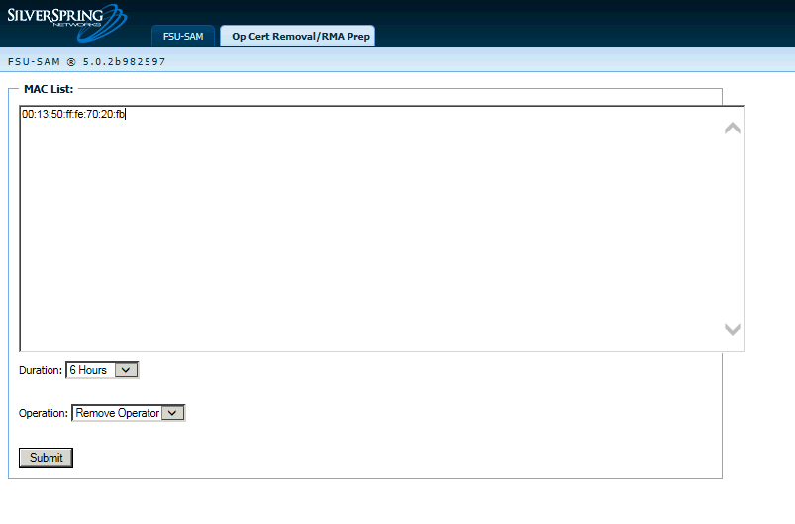
If you see error such as below, go back to NOC/UIQ Support for troubleshooting. It is likely that Cert in step 5.1 is not done properly.
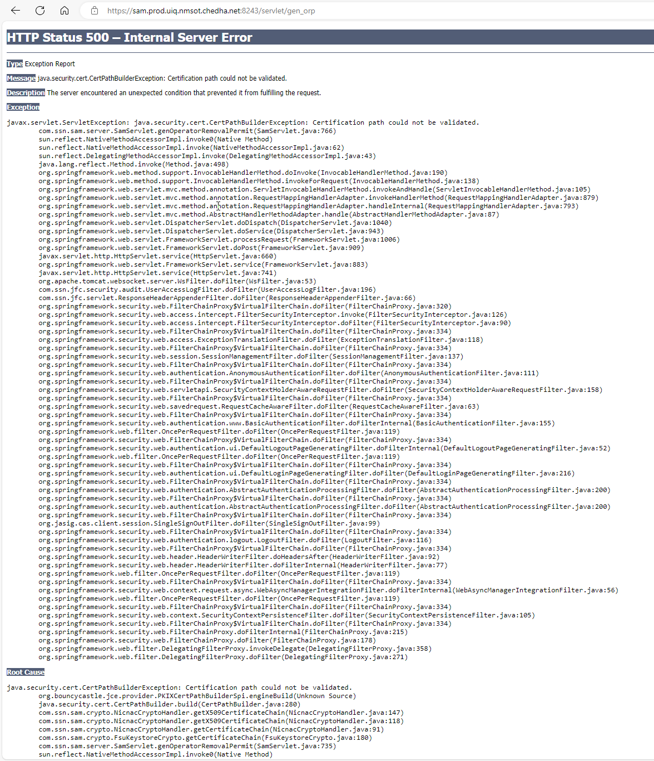
  - CATT Operation

Use an FSU that AMI Device are bond to, and in this example it is the Prod FSU.

Connect to the target AP securely via CATT
- first query the legacy port by using command “Disable LegacyPort, Get”
- If the Legacy port is disabled, enable it by using command “Disable LegacyPort, Set”,
In the command set Input Parameters “Disable” to “open”.

This step is important, otherwise new lua scripts will fail to upload. All below steps can be done in Clear Text connection in CATT.

- Use command “Op Cert, Delete”, Input Parameters “File Name” pick the permit.zip file downloaded from FSU-SAM in Step 5.2. Run it using “Run NULL Role” button.
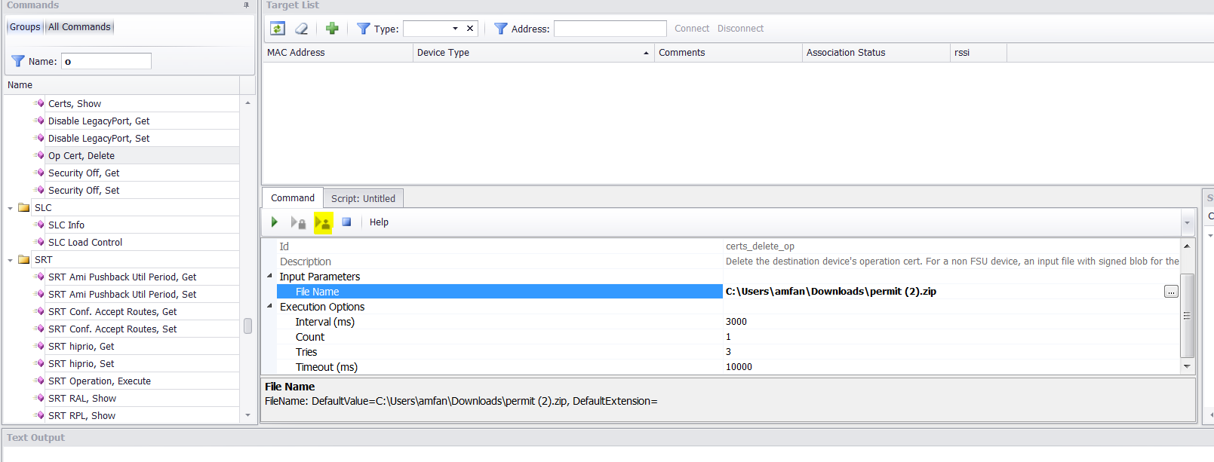

You will see two lines in the Text Output. Both ended with “OK”.
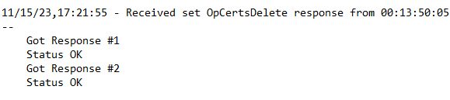

Note: If you only get 1 “OK”, run “Cert, Show” command next. It may show that both ODELPERMIT and Operator cert exist on the device:
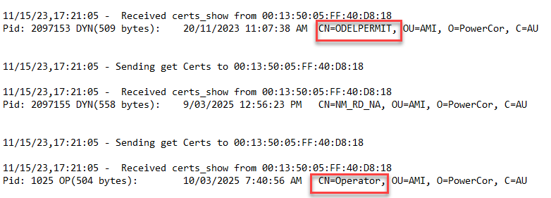
If you devices shows above, then this is not a successful Cert removal operation. Repeat command “Op Cert, Delete”, , reboot device or restart CATT if necessary, until you get two “OK” responses.

Run “Certs, Show” command again to confirm that BOTH Operator and ODELPERMIT no longer exist on the device.
Pid: 1025 OP(504 bytes): 10/03/2025 7:40:56 AM CN=Operator, OU=AMI, O=PowerCor, C=AU
Pid: 2097153 DYN(509 bytes): 20/11/2023 11:07:38 AM CN=ODELPERMIT, OU=AMI, O=PowerCor, C=AU

- Referenced Documents

Table 1: Referenced Documents
Title | Document No.
Repurposing AP5 Micro AP into another UIQ environment.docx
Removing_Operator_Certificates_From_NICs_and_Preparing_NICs_for_RMA.pdf

